Topic : Artificial Insemination. Unit III (2)

Artificial insemination (AI)

is the manual placement of semen in the reproductive tract of the female by a method other than natural mating which is one of a group of technologies commonly known as "assisted reproduction technologies" (ART), whereby offspring are generated by facilitating the meeting of gametes (spermatozoa and oocytes). AI is by far the most common method of breeding of intensively kept dairy cattle. In developed countries, advances in artificial insemination have already had a major impact on livestock improvement programmes. AI speeds up genetic progress, reduces the risk of disease transmission and expands the number of animals that can be bred from a superior parent. The acceptance of AI technology worldwide provided the impetus for developing other technologies, such as cryopreservation and sexing of sperm, estrous cycle regulation, and embryo harvesting, freezing, culture and transfer, and cloning.
here.

1).Method of semen collection

Methods commonly used for semen collection
1 )Bull :artificial-vagina, electroejaculation, massage, directly from vagina
2 )Ram and buck :directly from vagina, artificial vagina, electroejaculation
3 )Boar :using glove hand and artificial vagina
4 )Stallion :using artificial vagina
5 )Dog :using digital manipulation and using artificial vagina.

2.Evaluation of semen

1. Macroscopic evaluation
2. Microscopic evaluation

2.1 Macroscopic evaluation

The semen should be transferred to a water bath maintained at
35±1 °C. Visual evaluation for volume, colour,
consistency/density, odour and observation for presence of
foreign material (blood, pus cells, dung, hair, etc.) shall be
made and recorded. If dung or hair is found in the semen,
filtration with special semen filter is done.

2.2 Microscopic examination

Microscopic evaluation is done using a simple or phase
contrast microscope for mass activity (wave motion) and
individual motility. Determination of concentration is done
with a hemocytometer or a calibrated photometer. At this
point if required smears can be made for morphological
studies and live/dead count. Nigrosin-eosin stain is
recommended. Buffered nigrosin-eosin solution is mixed with
a drop of semen and smeared on a glass slide for
morphological examination. It should be dried and examined
under oil immersion. Automated computerised machines for
recording motility and concentration and calculating the
required extensions are normally used where ever affordable.

Various biochemical tests used for asses the sperm fertility

1. Methylene blue reduction test
2. Cold shock resistance test
3. Zone free hamster egg penetration test
4. Sperm mucus penetration test
5. Hypo-osmotic swelling test
6. Computer assisted semen evaluation
7. Fructolysis index
8. Oxygen utilization test
9. Millovanov’s resistance test
10. Hyaluronidase content.

. Dilution of semen

The first major improvement in the AI procedure was the development of a yolk-phosphate semen extender (Phillips and Lardy, 1940) Salisbury et al. (1941) improved the media by buffering the egg yolk with sodium citrate. Extender preserves fertilizing capacity of the spermatozoa for long period and increases the volume and thereby services to large number of females.

Dilutor provide viability and fertility of spermatozoa for prolong period. Ideal semen dilutor should be isotonic with the seminal plasma, have a pH of 6.6 to 6.8 with high buffering capacity contain
lipoproteins and lecithin, minerals in adequate quality and substances used for aerobic as well as anaerobic metabolism by the spermatozoa and glycerol. It should contain fructose to supply energy to sperm and antibiotic control of microbes.

The qualities of a good semen extender outlined by Samad (1985)

1. )Osmotic pressure and electrolyte balance Equipment of seminal plasma(285 millimoles)
2. )Energy source Glucose,Fructose and Lactose in appreciable quantities.
3 )Buffering capacity Should maintain pH of diluted semen.
4. )Protection against cold shock Lecitten,Lipoprotein as casine in milk and egg yolk Protect against cold shock
5. )Cryoprotectant Glycerol
6. )Antibiotics

4. Packing

Packing of semen is done in medium straw (0.5 ml volume)
and mini straw (0.25 ml volume). Medium straw have a 3 mm size

5)Semen preservation
Semen is used either immediately after collection (“fresh”) for
example turkeys, human beings; after storage at a reduced
temperature (“stored”) for example horses, pigs, dogs; or after
freezing and thawing (“cryopreservation”) for example, bulls.

Cryopreservation
Semen is most useful for AI if it can be cryopreserved, since
this method of preservation ideally enables the semen to be
stored for an unlimited time without losing quality.

Thawing semen in warm-water (35-38 °C) for 40 seconds is
the most commonly used thawing procedure reported by
inseminators (80%). A significant increase in the conception
rate (27%) was reported when thawing occurred in warm-
water (33-35°C) as opposed to air (Dejarnette and Marshall,
2005)6. Kaproth et al. (2005) [7] also reported a significant in-
crease (62.4%) in the fertility rate when thawing is done in
warm-water 35 °C

7)Procedure for insemination

Firstly, it has to be ensured that the cow to be bred is truly in
heat. The cow should be restrained at first and then semen
should be thawed. The restraint area should be familiar to the
cow and free of stressful conditions. The tail is moved and the
cow is cleaned to remove any excess manure and debris from
the vulva. The gun is unwrapped and then inserted at a 30°-
40° angle into the cow’s vulva. The left hand is inserted into
the rectum to check for the location of the end of the AI gun.
The cervix is grasped with the hand in the rectum of the cow
and is held steadily while the AI gun is thread into the cervix
of the cow. When the AI gun is all the way through the
cervix, the location is checked with index finger. The AI gun
should be only ½ to ¼ of an inch into the uterus. Slowly the
plunger is depressed at the end where the right hand is so that
½ of the straw’s contents is deposited.

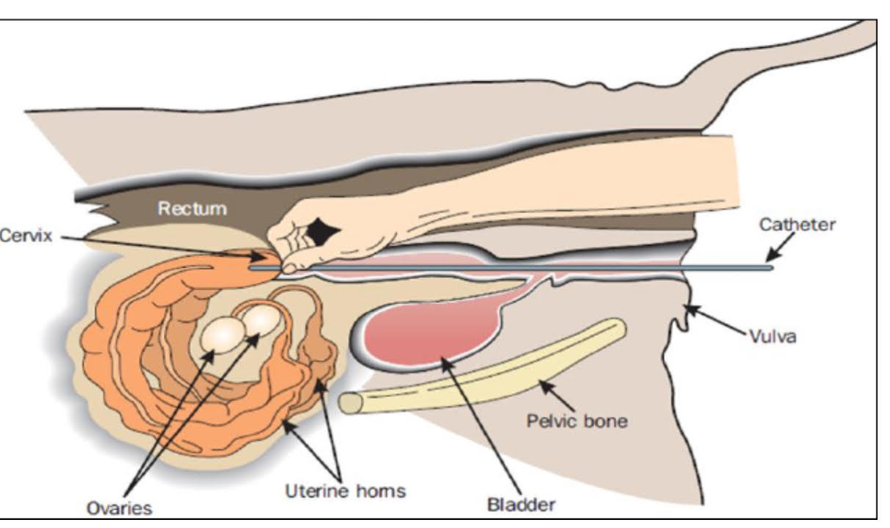

Correct timing of insemination is as important as correct
placement of semen. Field experience has shown that the best
results are obtained when the insemination is performed at or
near the end of oestrus. The beginning and end of oestrus are
very difficult to determine. The simplest practical method of
timing inseminations is to use the a.m.- p.m. rule.

Cows first seen on heat Insemination time
Morning (a.m.) Same afternoon (p.m.)
Afternoon (p.m.) Next morning (a.m.)
Two-thirds of cows commence oestrus at night and so will
first be seen on heat in the morning. With heifers and some
Bos indicus breeds, many authorities do not recommend the
a.m.– p.m. rule. They recommend that these animals should
be inseminated soon after the first observed oestrus

AI. Advantages and Disadvantages

Advantages

1. Increased efficiency: During natural breeding, a male will deposit much more semen than is theoretically needed to produce a pregnancy. In addition, natural breeding is physically stressful. Both of these factors limit the number of natural matings a male can make. However, collected semen can be diluted and extended to create hundreds of doses from a single ejaculate. Also, semen can be easily transported, allowing multiple females in different geographical locations to be inseminated simultaneously, and semen can be stored for long periods of time, meaning that males can produce offspring long after their natural reproductive live end.
2. Increased potential for genetic selection: Because artificial insemination allows males to produce more offspring, fewer males are needed. Therefore, one can choose only the few best males for use as parents, increasing the selection intensity. Furthermore, because males can have more offspring, their offspring can be used in a progeny test program to more accurately evaluate the genetic value of the male. Finally, individual farmers can use artificial insemination to increase the genetic pool with which his or her animals can be mated, potentially decreasing effects of inbreeding.
3. Increased safety for animals and farmers: As mentioned, male animals can become large and aggressive. These factors mean that maintaining a bull on a farm may be dangerous. Also, because of the relatively larger size of adult males than females, natural mating is more likely to result accidents and injury to either the cow or the bull than is artificial insemination.
4. Reduced disease transmission: Exposure of sires to infectious genital diseases is prevented by use of AI which reduces the danger of spreading such diseases (Webb, 1992) [8]. In other way, if only males known to be free from disease are selected for semen collection, artificial insemination can play an important part in controlling diseases spread through sexual contact. Among the diseases in this group are granular vaginitis, trichomoniasis, navel ill, dourine, brucellosis and coital exanthema.
5. Improving animals’ productivity: AI plays an important role in enhancing animal productivity, especially milk yields, in developing countries that have a well-defined breeding strategy and a sound technical base to absorb and adapt the technology to meet their needs (BBC, 2015) [9]. Daughters of AI sires produce significantly more milk than those of herd bulls sires and the income from this extra milk may cover the extra costs resulting from extended calving intervals because of low heat detection.
6. Breeding can occur in the event of physical, physiological or behavioural abnormalities;
7. AI is a powerful tool when linked to other reproductive biotechnologies such as sperm cryopreservation, sperm sexing.
8. AI can be used in conservation of rare breeds or endangered species.
9. The use of semen extenders containing antibiotics also helped to prevent the transmission of bacterial diseases.

Disadvantage

1. Cost of AI compared to natural service: Despite the well-known advantages of artificial insemination, a large number of dairy farmers all over the world still use natural service (NS) bulls to breed their cows. The main arguments allegedly justifying their choice are higher AI costs compared to those of keeping herd bulls and additional costs resulting from extended calving intervals because of low heat detection rates when AI is used.
2. Impact of AI in genetic diversity: Even though AI is highly effective in improving animals’ productivity, there is also a concern that its inappropriate or unplanned usecan lead to increased rates of genetic erosion and breed extinction (Pilling et al., 2007) [10]. The heavy use of the best males results in a strong increase in inbreeding and a lose of genetic diversity.
3. Difficulty of heat detection: Among different factors that can affect conception rate per AI service, accuracy of heat (estrus) detection is the major one that determines AI program since ova remains viable for only about 12-18 hours after ovulation (Bekana, 1991) [11]. The failure to detect heat is the most common and costly problem of AI programs and the major limiting factor of reproductive performance on many dairies

References:
Philips s PH, Lardy HA. A yolk-buffer pabulum for the preservation of bull semen. J Dairy Sci. 1940; 23:399-404. 2. Salisbury GW, Fuller HK, Willett EL. Preservation of bovine spermatozoa in yolk-citrate diluent and field results from its use. J. Dairy Sci. 1941; 24:905-910. 3. Samad SA. Diluters of the Buffalo Semen. Processing and use of Buffalo semen. Ani. Sci. Inst. NARC, Islamabad, 1985, 34-46. 4. Hopkins SS, Evans LE. Artificial Insemination. In: Veterinary Endocrinology and Reproduction. 4th Ed. MacDonald, L.E. and Pineda, M.H., (eds). Philadelphia, Lea and Feibeger, 1989, 354-88, 5. Merck. The Merck Veterinary Manual, 5th Ed, 1983. 6. Dejarnette JM, Marshall CE. Straw-thawing method interacts with sire and extender to influence sperm motility and conception rates of dairy cows. J. Dairy Sci.

